补充内容
- 增加车辆照片（正、背面）
图片1：
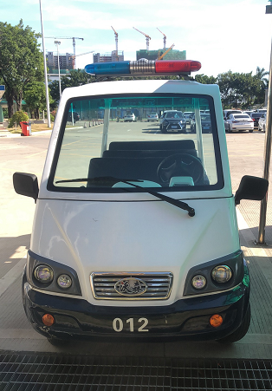
图片2：
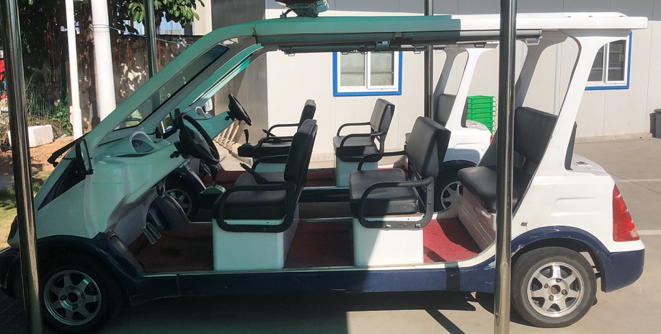

图片3：
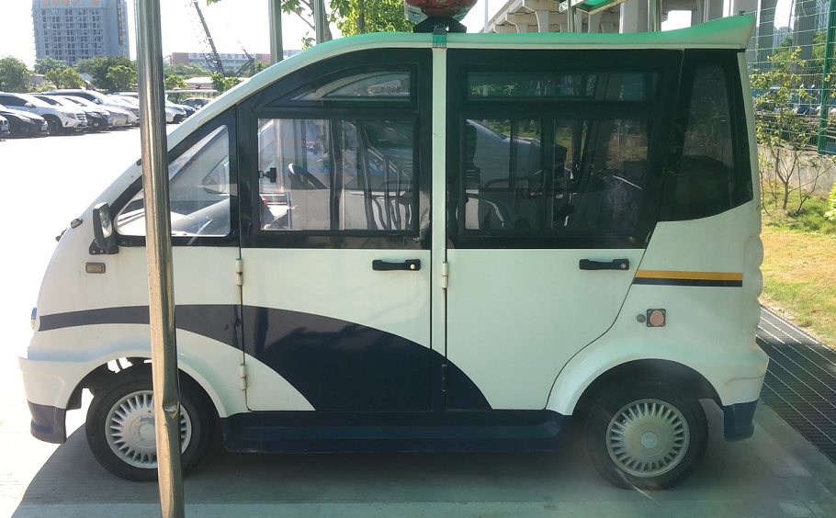
图片4：
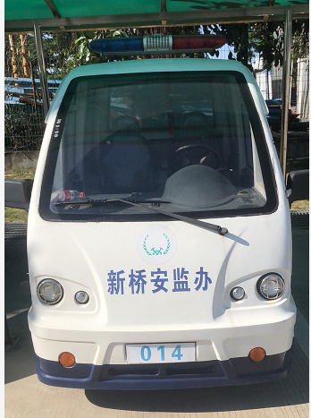
- 车辆相关信息
拟定编号 | 车牌号 | 车架号 | 车型号 | 产品车型
001 | 1704006360 | GP1C0001704006360 | WS-FB4PW | 沃森4座封闭巡逻车
002 | 1705006027 | GP1C0001705006027 | WS-FB4PW | 沃森4座封闭巡逻车
003 | 170270 | GP1C0000017080210 | WS-A6P | 沃森蓄电池观光车
004 | 170302 | GP1C0000017080207 | WS-A6P | 沃森蓄电池观光车
005 | 704460 | GP1C0000001704460 | LQX080 | 朗晴电动巡逻车
006 | 704461 | GP1C0000001704461 | LQX080 | 朗晴电动巡逻车
007 | 704463 | GP1C0000001704463 | LQX080 | 朗晴电动巡逻车
008 | 807430 | L4MGKGM61JA000639 | DN-8-6 | 玛西尔悍马巡逻车
009 | 807431 | L4MGKGM6XJA000641 | DN-8-6 | 玛西尔悍马巡逻车
010 |  | L4MGKEM48KA002229 | DN-4-6 | 玛西尔悍马巡逻车
011 |  | L4MGKEM44KA002227 | DN-4-6 | 玛西尔悍马巡逻车
012 |  | L4MGKEM42KA002226 | DN-4-6 | 玛西尔悍马巡逻车
013 |  | L4MGKEM46KA002228 | DN-4-6 | 玛西尔悍马巡逻车
014 | 1712007750 | GP1C0001712007750 | WS-FB4PW | 沃森4座封闭巡逻车
015 | 1801007828 | GP1C0001801007828 | WS-FB4PW | 沃森4座封闭巡逻车
016 | 1801007847 | GP1C0001801007847 | WS-FB4PW | 沃森4座封闭观光车
017 | 1711007484 | GP1C0001711007484 | WS-FB4PW | 沃森4座封闭观光车
018 | 1702006207 | GP1C0001702006207 | WS-FB4PW | 沃森4座封闭巡逻车
019 | 1708169 | GP1C0000017090266 | WS-A8P | 沃森蓄电池观光车
020 | 1708216 | GP1C0000017090267 | WS-A8P | 沃森蓄电池观光车
021 | 1708228 | GP1C0000017090268 | WS-A8P | 沃森蓄电池观光车
022 | 1708232 | GP1C0000017090269 | WS-A8P | 沃森蓄电池观光车
023 | 1708247 | GP1C0000017090270 | WS-A8P | 沃森蓄电池观光车
024 | 1708212 | GP1C0000017090271 | WS-A8P | 沃森蓄电池观光车
025 | 1708240 | GP1C0000017090272 | WS-A8P | 沃森蓄电池观光车
026 | 1708164 | GP1C0000017090273 | WS-A8P | 沃森蓄电池观光车
027 | 1708207 | GP1C0000017090274 | WS-A8P | 沃森蓄电池观光车
028 | 1708167 | GP1C0000017090275 | WS-A8P | 沃森蓄电池观光车
029 | 1712215 | GP1C0000018040043 | WS-HY2 | 沃森蓄2座电动货车
030 | 1712180 | GP1C0000018040044 | WS-HY2 | 沃森蓄2座电动货车
031 | 1712182 | GP1C0000018040038 | WS-HY2 | 沃森蓄2座电动货车
032 | 1712185 | GP1C0000018040046 | WS-HY2 | 沃森蓄2座电动货车
033 | 1712047 | GP1C0000018040039 | WS-HY2 | 沃森蓄2座电动货车
034 | 1712066 | GP1C0000018040040 | WS-HY2 | 沃森蓄2座电动货车
035 | 1712227 | GP1C0000018040042 | WS-HY2 | 沃森蓄2座电动货车
036 | 1712061 | GP1C0000018040041 | WS-HY2 | 沃森蓄2座电动货车
037 | 1712055 | GP1C0000018040037 | WS-HY2 | 沃森蓄2座电动货车
038 | 1712202 | GP1C0000018040045 | WS-HY2 | 沃森蓄2座电动货车
039 | 1704462 | GP1C0000001704462 | LQX080 | 朗晴电动巡逻车
040 | 1704464 | GP1C0000001704464 | LQX080 | 朗晴电动巡逻车
041 | 1904-0019 | 482519040100BAXQ121 | 1904-0019 | 沃森电动巡逻车
042 | 1904-0020 | 482519040100BAXQ122 | 1904-0020 | 沃森电动巡逻车
043 | 1801007834 | GP1C0000018010078 | WS-FB4PW | 沃森4座封闭巡逻车
044 | 1712044 | GP1C0000018040036 | WS-A6P | 沃森8座电动巡逻车
045 | 1712189 | GP1C0000018040035 | WS-A6P | 沃森8座电动巡逻车
046 | 1800344 | L4MGKGM63JA000643 | DN-8-6 | 玛西尔悍马巡逻车
047 | 704465 | GP1C0000001704465 | LQX080 | 朗晴电动巡逻车
048 | 704453 | GP1C0000001704453 | LQX080 | 朗晴电动巡逻车
049 | 1704006361 | GP1C0001704006361 | WS-FB4PW | 沃森4座封闭巡逻车
050 | 1703006350 | GP1C0001703006350 | WS-FB4PW | 沃森4座封闭巡逻车
051 | 1703006354 | GP1C0001703006354 | WS-FB4PW | 沃森4座封闭巡逻车
052 | 170411 | GP1C0000017100291 | WS-HY2 | 沃森蓄电池观光斗车
053 | 000645 | L4MGKGM67JA000645 | DN-8-6 | 玛西尔悍马巡逻车
054 | 160149 | GP1C0011060160149 | WS-MX4P | 沃森4座敞篷巡逻车
055 | 140147 | GP1C0011060140147 | WS-MX4P | 沃森4座敞篷巡逻车
056 | 190152 | GP1C0011060190152 | WS-MX4P | 沃森4座敞篷巡逻车
057 | 170150 | GP1C0011060170150 | WS-MX4P | 沃森4座敞篷巡逻车
058 | 180151 | GP1C0011060180151 | WS-MX4P | 沃森4座敞篷巡逻车
059 | 150148 | GP1C0011060150148 | WS-MX4P | 沃森4座敞篷巡逻车
060 | DZ170194 | GP1C0000017060166 | WS-A8P | 沃森蓄电池观光车
061 | DZ160115 | GP1C0000017060157 | WS-A8P | 沃森蓄电池观光车
062 | DZ170200 | GP1C0000017060159 | WS-A8P | 沃森蓄电池观光车
063 | 170384 | GP1C0000017100295 | WS-HY2 | 沃森蓄电池观光车
064 | 170340 | GP1C0000017100299 | WS-HY2 | 沃森蓄电池观光车
065 | 170266 | GP1C0000017080205 | WS-A6P | 沃森蓄电池观光车
066 | 170315 | GP1C0000017080206 | WS-A6P | 沃森蓄电池观光车
067 | 1703006071 | GP1C0001703006071 | WS-FB4PW | 沃森4座封闭巡逻车
068 | 1704006082 | GP1C0001704006082 | WS-FB4PW | 沃森4座封闭巡逻车
069 | 807427 | L4MGKGM65JA000644 | DN-8-6 | 玛西尔悍马巡逻车
070 | 1909-0050 | 48251909260021 | WS-HY4 | 沃森4座电动货车
071 | DZ170204 | GP1C0000017060155 | WS-A8P | 沃森蓄电池观光车
072 | DZ170250 | GP1C0000017060153 | WS-A8P | 沃森蓄电池观光车
073 | 170323 | GP1C0000017100301 | WS-HY2 | 沃森蓄电池观光车
074 | 170335 | GP1C0000017100300 | WS-HY2 | 沃森蓄电池观光车
075 | 170388 | GP1C0000017100297 | WS-HY2 | 沃森蓄电池观光车
076 | 1702006016 | GP1C0001702006016 | WS-FB4PW | 沃森4座封闭巡逻车
077 | 1703006077 | GP1C0001703006077 | WS-FB4PW | 沃森4座封闭巡逻车
078 | 1703006078 | GP1C0001703006078 | WS-FB4PW | 沃森4座封闭巡逻车
079 | 000646 | L4MGKGM69JA000646 | DN-8-6 | 玛西尔悍马巡逻车
080 | 170100006 | GP1C0000017080209 | WS-A6P | 沃森蓄电池观光车
081 | 17060169 | GP1C0000017060169 | WS-A8P | 沃森蓄电池观光车
082 | GP1C0000017060163 | GP1C0000017060163 | WS-A8P | 沃森蓄电池观光车
083 | DZ170209 | GP1C0000017060156 | WS-A8P | 沃森蓄电池观光车
084 | 170382 | GP1C0000017100304 | WS-HY2 | 沃森蓄电池观光车
085 | 170385 | GP1C0000017100303 | WS-HY2 | 沃森蓄电池观光车
086 | 001168 | L4MGKEK47JA001168 | DN-4-6 | 玛西尔悍马巡逻车
087 | 1705006371 | GP1C0001705006371 | WS-FB4PW | 沃森4座封闭巡逻车
088 | 1706006444 | GP1C0001706006444 | WS-FB4PW | 沃森4座封闭巡逻车
089 | 1704006083 | GP1C0001704006083 | WS-FB4PW | 沃森4座封闭巡逻车
090 | 1704006084 | GP1C0001704006084 | WS-FB4PW | 沃森4座封闭巡逻车
091 | 1705006375 | GP1C0001705006375 | WS-FB4PW | 沃森4座封闭巡逻车
092 | 1704006364 | GP1C0001704006364 | WS-FB4PW | 沃森4座封闭巡逻车
093 | 170292 | GP1C0000017080201 | WS-A6P | 沃森蓄电池观光车
094 | 170301 | GP1C0000017080202 | WS-A6P | 沃森蓄电池观光车
095 | 1304010-0182 | WS-A8P1304010-0182 | WS-A8P | 沃森蓄电池观光车
096 | TS2532001-2023 | LLTGGCXM8LB000222 | LT07-A07P22-W5 | 蓝涂新能源蓄电池电动货车
097 | 1507084-0400 | WS-1507084-0400 | WS-A6P | 沃森蓄电池观光车
098 | 170436 | GP1C0000017100294 | WS-HY2 | 沃森蓄电池观光车
099 | 170336 | GP1C0000017100298 | WS-HY2 | 沃森蓄电池观光车
100 | 170408 | GP1C0000017100296 | WS-HY2 | 沃森蓄电池观光车
101 | DZ170155 | GP1C0000017060151 | WS-A8P | 沃森蓄电池观光车
102 | DZ170198 | GP1C0000017060158 | WS-A8P | 沃森蓄电池观光车
103 | 170316 | GP1C0000017080208 | WS-A6P | 沃森蓄电池观光车
104 | 170302 | GP1C0000017080207 | WS-A6P | 沃森蓄电池观光车
105 | 1706006438 | GP1C0001706006438 | WS-FB4PW | 沃森4座封闭巡逻车
106 | 1704006089 | GP1C0001704006089 | WS-FB4PW | 沃森4座封闭巡逻车
107 | 1705006429 | GP1C0001705006429 | WS-FB4PW | 沃森4座封闭巡逻车
108 | 1703006072 | GP1C0001703006072 | WS-FB4PW | 沃森4座封闭巡逻车
109 | 170334 | GP1C0000017100302 | WS-HY2 | 沃森蓄电池观光车
110 | 170401 | GP1C0000017100307 | WS-HY2 | 沃森蓄电池观光车
111 | DZ170192 | GP1C0000017060150 | WS-A8P | 沃森蓄电池观光车
112 | 170285 | GP1C0000017080200 | WS-A6P | 沃森蓄电池观光车
113 | 170312 | GP1C0000017080199 | WS-A6P | 沃森蓄电池观光车
114 | DZ170191 | GP1C0000017060167 | WS-A8P | 沃森蓄电池观光车
115 | 190220 | GP1A8P13040190220 | WS-A8P | 沃森蓄电池观光车
116 |  | LFJKYC334H0003174 | 特种车PICKMAN | 常力四轮消防电动车
117 |  | LFJKYC333H0003179 | 特种车PICKMAN | 常力四轮消防电动车
118 |  | LFJKYC339H0003171 | 特种车PICKMAN | 常力四轮消防电动车
119 | DZ170165 | GP1C0000017060154 | WS-A8P | 沃森蓄电池观光车
120 | 170410 | GP1C0000017100306 | WS-HY2 | 沃森蓄电池观光车
121 | 170342 | GP1C0000017100292 | WS-HY2 | 沃森蓄电池观光车
122 | DZ170183 | GP1C0000017060160 | WS-A8P | 沃森蓄电池观光车
123 | DZ170153 | GP1C0000017060162 | WS-A8P | 沃森蓄电池观光车
124 | 170314 | GP1C0000017080211 | WS-A6P | 沃森蓄电池观光车
125 | 170306 | GP1C0000017080212 | WS-A6P | 沃森蓄电池观光车
126 | 1704006359 | GP1C0001704006359 | WS-FB4PW | 沃森4座封闭巡逻车
127 | 1703006081 | GP1C0001703006081 | WS-FB4PW | 沃森4座封闭巡逻车
128 | 1704006077 | GP1C0001704006077 | WS-FB4PW | 沃森4座封闭巡逻车
129 | 1703006351 | GP1C0001703006351 | WS-FB4PW | 沃森4座封闭巡逻车
130 | DZ170193 | GP1C0000017060168 | WS-A8P | 沃森蓄电池观光车
131 | 000640 | L4MGKGM61JA000640 | DN-4-6 | 玛西尔悍马巡逻车
132 | 000642 | L4MGKGM61JA000642 | DN-4-6 | 玛西尔悍马巡逻车
133 | 170398 | GP1C0000017100305 | WS-HY2 | 沃森蓄电池观光车
134 | 170324 | GP1C0000017100293 | WS-HY2 | 沃森蓄电池观光车
135 | DZ170201 | GP1C0000017060152 | WS-A8P | 沃森蓄电池观光车
136 | 170313 | GP1C0000017080203 | WS-A6P | 沃森蓄电池观光车
137 | 1704006358 | GP1C0001704006358 | WS-FB4PW | 沃森4座封闭巡逻车
138 | 170319 | GP1C0000017080204 | WS-A6P | 沃森蓄电池观光车
139 | DZ170208 | GP1C0000017060165 | WS-A8P | 沃森蓄电池观光车
140 | 000647 | L4MGKGM60JA000647 | DN-8-6 | 玛西尔悍马巡逻车
141 | 1708004661 | GP1C0GD1708004661 | LND-MX4 | 绿能达四座电动巡逻车
142 | 1708004660 | GP1C0GD1708004660 | LND-MX4 | 绿能达四座电动巡逻车
143 | 4825200114002 | WS-2001-0001 | WS-A8P | 沃森8座电动巡逻车
144 | 4825200114003 | WS-2001-0003 | WS-A8P | 沃森8座电动巡逻车
145 | 4825200114005 | WS-2001-0004 | WS-A8P | 沃森8座电动巡逻车
146 | 4825200114004 | WS-2001-0002 | WS-A8P | 沃森8座电动巡逻车
147 | 48251912170015 | WS-2001-0005 | WS-A8P | 沃森8座电动巡逻车
148 | 48251912170013 | WS-2001-0006 | WS-A8P | 沃森8座电动巡逻车
149 | 48251912170001 | WS-2001-0007 | WS-A8P | 沃森8座电动巡逻车
150 | 48251912170014 | WS-2001-0008 | WS-A8P | 沃森8座电动巡逻车
151 | 1712007805 | GP1C0001712007805 | 1712007805 | 沃森WS-FB8PW电动巡逻车
152 | 1703-24 |  | FB-V08 | 沃森蓄电池观光车
153 | 1703-25 |  | FB-V08 | 沃森蓄电池观光车
154 | 938527 | XF051200401-301 | XQ-4HV | 朗晴电动巡逻车

深圳市宝安区新桥街道办事处
2020年06月29日

